AVIATION NOISE - MONITORING

AND AIR TRAFFIC ORGANIZATION

IN THE AREA OF AIRPORT VASIL LEVSKI - SOFIA

AVIATION NOISE
Noise is unwanted sound that has both an objective, physical component and a subjective component.

The physical component is the energy transmitted through the air, which our ears detect as small changes in air pressure.

The subjective component considers the individual perception or reaction to a sound - some sounds may be pleasant to some, while others may consider them noise. For example, the barking of the neighbour’s dog in the middle of the night is more commonly perceived as annoying. Even sounds that are pleasant at a certain volume - soft music - can become noise when they are louder - a rock concert.

There's no denying that aviation is noisy. During landing and take-off, depending on the type of aircraft and its altitude, it causes significant noise as it flies overhead.

Aviation noise is noise pollution caused by aircraft or its components. Most of the noise is generated by the aircraft's engines, but also by the airframe and various onboard systems, such as the air conditioning system.
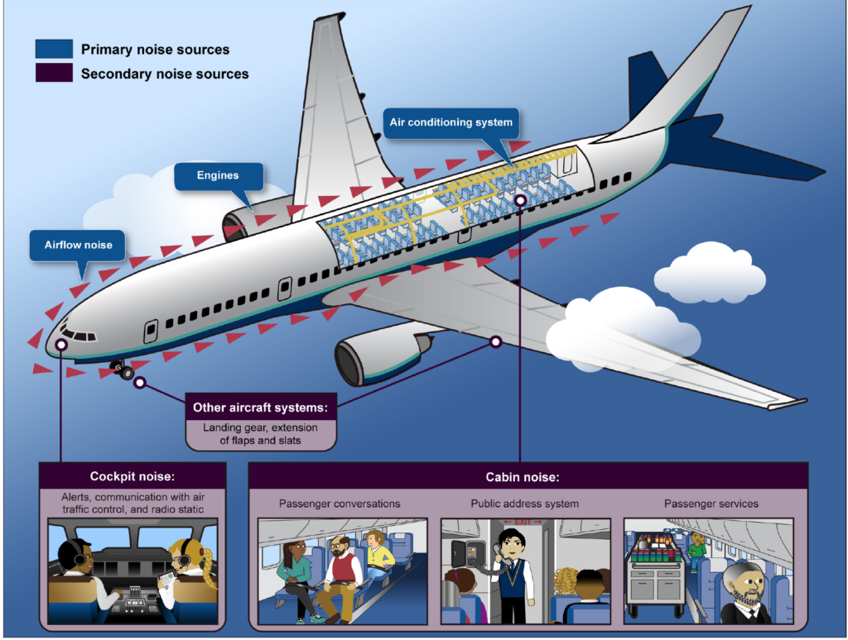
Even if (hypothetically) the aircraft engines do not work, when air passes over the airframe, it causes friction and turbulence, which results in noise. The level of noise generated varies according to aircraft size and type and can differ even for identical aircraft.

Aircraft noise is usually the main environmental problem for settlements near airports.

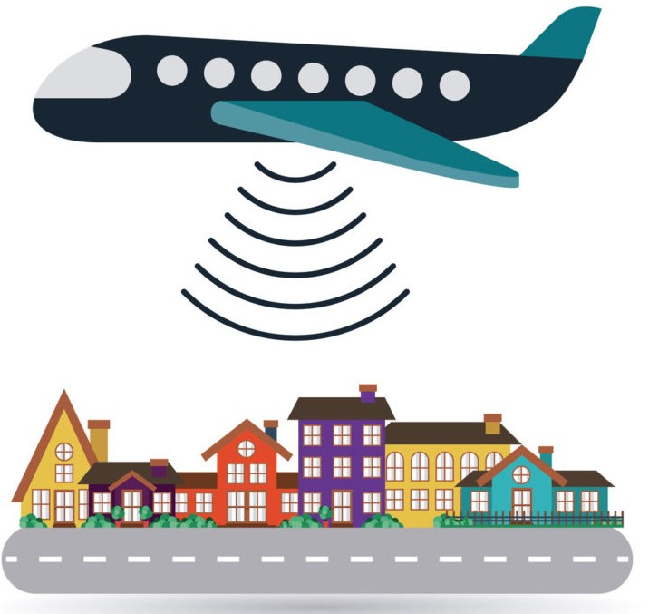

It is also the most significant reason for submission of signals and complaints. This trend is expected to continue in most regions of the world for the foreseeable future.

Regulatory framework
Noise indicators and limit values in Bulgaria are regulated by Ordinance No. 6 of June 26, 2006 on environmental noise indicators, taking into account the degree of discomfort during different parts of the day, the limit values of environmental noise indicators, methods for assessing the values of noise indicators and the harmful effects of noise on the health of the population , issued by the Ministry of Health and the Ministry of Environment and Water.

Noise indicators are physical quantities that determine environmental noise, considering the limits and degree of discomfort of people exposed to noise, depending on the nature of the noise, the time of day, the purpose of the living premises, the nature of the territories and zones in and outside urbanized areas.

The main noise indicators are:
- Day noise level: Lday - noise indicator related to discomfort during the daytime period (from 7 to 19 hrs for a duration of 12 hours);
- Evening noise level: Levening - an indicator of noise related to discomfort during the evening period (from 19 to 23 hrs for a duration of 4 hours);
- Night noise level: Lnight - an indicator of noise related to sleep disturbance at night (from 23 to 7 hrs for a duration of 8 hours);
- 24-hour noise level: L24 (Lden) - an indicator of noise related to discomfort throughout the day and is determined by a calculation method from the values of Lday , Levening and Lnight.
The limit values of noise levels in the various territories and development zones in urbanized territories and outside them are given in Annex No. 2 to Art. 5 of the Ordinance:

No. | Territories and development zones in urbanized areas and outside them | Equivalent noise level in dB(A)
No. |  | day | evening | night
1 | Residential areas and territories | 55 | 50 | 45
2 | Mixed inner city areas | 60 | 55 | 50
3 | Areas affected by heavy traffic | 60 | 55 | 50
4 | Territories affected by rail and tram transport | 65 | 60 | 55
5 | Areas affected by aircraft noise | 65 | 65 | 55
6 | Production and warehouse territories and zones | 70 | 70 | 70
7 | Areas for public and individual recreation | 45 | 40 | 35
8 | Zones for medical facilities | 45 | 35 | 35
9 | Areas for scientific research and teaching activities | 45 | 40 | 35
10 | Quiet areas outside urban areas | 40 | 35 | 35
Note: The maximum noise level limit for aircraft flying over a certain territory is 85 dB(A).

The limit values are in full compliance with the recommendations of the World Health Organization.

Noise abatement procedures at Vasil Levski Airport - Sofia
The noise abatement procedures at Airport Vasil Levski - Sofia are published in the AIP Republic of Bulgaria, in section LBSF AD 2.21.

Procedures include (but are not limited to):
- Ban on intersection take-off from RWY27 between 22:00 and 07:00 local time;
- Recommended approach with continuous descent (CDA) upon landing;
- Recommended engines small throttle "reverse" mode after landing between 23:00 and 06:00 local time;
- Noise preferential runway for take-off is RWY09;
- Noise preferential runway for landing is RWY27;
- Prohibition on conducting test flights and maintenance flights between 23:00 and 06:00 local time;
- Restrictions on conducting training flights between 23:00 and 06:00 local time;
- Prohibition on conducting ground tests of engines (run-ups) at engine mode higher than "low throttle" between 23:00 and 06:00 local time.
etc.

The aircraft commander may deviate from noise abatement procedures only in the interest of flight safety.

The possibilities for avoiding aircraft overflights over the city of Sofia depend on several factors which BULATSA and the airport operator cannot influence (such as weather conditions, aircraft weight, crew training, flight and technical condition of the given aircraft, restrictions arising from its flight operation manual). Also, due to the mutual location of the city and the runway of Airport Vasil Levski - Sofia, the unconditional requirements for flight safety necessitates in some cases aircraft to overfly certain areas of the capital, because these are the only possible ways to safely arrive at or depart from the airport.

Aviation noise monitoring
SOF Connect has a system for continuous aviation noise monitoring and flight tracking, put into operation at the end of 2004, and upgraded in mid-2015 by replacing the hardware and switching to the most up-to-date software platform in the field.

The system terminals are installed at monitoring sites located under the routes fordeparture from and arrival at Airport Vasil Levski - Sofia:

Terminal W 1 – western end of Sofia Airport approximately 920 m west of threshold 09 of runway (RUT09);
Terminal W2 – V. Levski quarter, 18 “Gr. Tsamblak ” Str., roof of 106 “Gr. Tsamblak ” Primary School;
Terminal W3 – Suha Reka district, Poduyane district, 51 Plakalnitsa Street, roof of the municipality building;
Terminal W4 – Suha Reka district, Poduyane district, 1 Khan Sevar Street, roof of 74 DG “Daga”;
Terminal W5 – Oborishte district, 62 Iskar Street, the building of the Academician Andrey Stoyanov Community Center;
Terminal W6 – Vazrazhdane district, 48 Bregalnitsa Street, 1 DG building;
Terminal E1 – eastern end of Sofia Airport, approximately 960 m east of threshold 27 of the runway;
Terminal E2 – village of Krivina-1588, 1 Prosveta Street, yard of 155 Primary School “St. Cyril and Methodius”;
Mobile terminal E3 – the terminal is intended for short-term control measurements.
Noise recording in the westerly direction, which covers a densely populated urban area, is carried out using the terminals W1, W2, W3, W4, W5 and W6, and in the east direction from terminals E1 and E2.

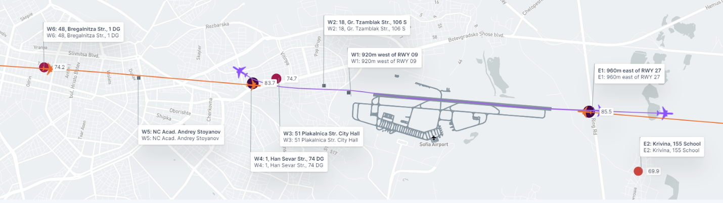

Information about aviation noise in the area of Vasil Levski Airport - Sofia
Information about aviation noise in the area of Vasil Levski Airport - Sofia is published monthly on the airport's website at:
https://sofia-airport.eu/bg/ustoichivost/dokladi-ot-monitoring-na-aviatsionen-shum/

Statistics
Year | % landings on runway 09 | % of takeoffs from runway 27 | % of landings on RU27 | % of takeoffs from RU 09
2019 | 29 | 54 | 71 | 46
2020 | 21 | 56 | 79 | 44
2021 | 26 | 55 | 74 | 45
2022 | 21 | 59 | 79 | 41
2023 | 27 | 55 | 73 | 44
2024 | 31 | 53 | 68 | 47

AIR TRAFFIC ORGANIZATION

Roles and responsibilities
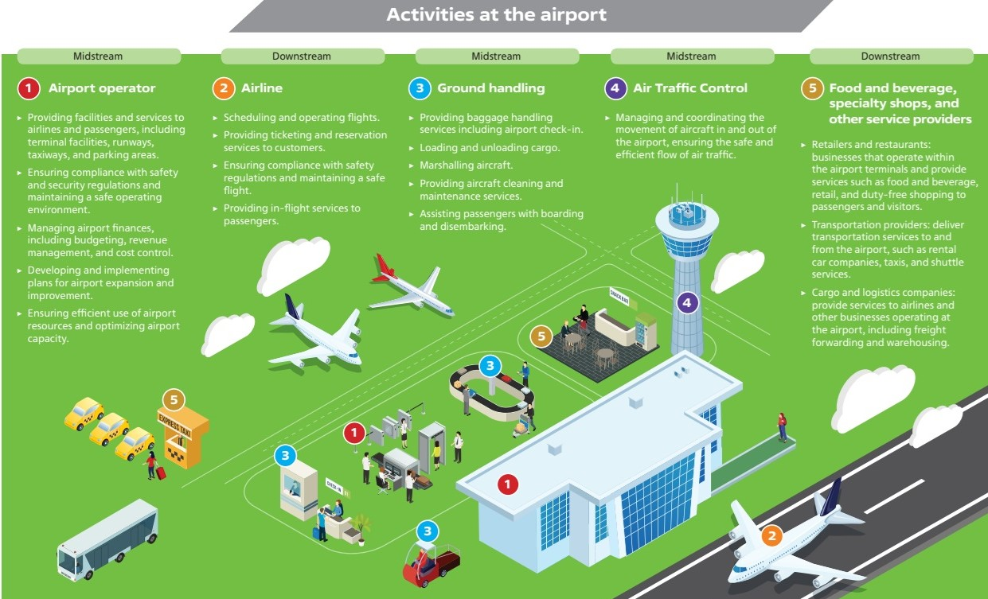

Regulatory and control functions in civil aviation
The regulatory and control functions in the field of civil aviation in the Republic of Bulgaria are performed by the Directorate General of Civil Aviation Administration (DG CAA) under the Ministry of Transport and Communications, in accordance with the Civil Aviation Act.
As part of these functions, the DG CAA approves the flight procedures (arrival, approach and departure) from/to Airport Vasil Levski - Sofia.
A flight procedure or instrumental flight procedure (IFP) is a set of predetermined manoeuvres with specified protection from obstacles designed to achieve safe flight operations and an orderly flow of air traffic. Flight procedures linked to an aerodrome are specified as arrival, departure or approach procedure and are published in the respective national Aeronautical Information and Publication (AIP).

Airport operations
SOF Connect AD (SOF Connect) manages and operates Airport Vasil Levski - Sofia in the function of airport operator since 20.04.2021, pursuant to the contract signed on 22.07.2020 for awarding a concession for Sofia Airport.
SOF Connect is a licensed operator of airport activities, which are carried out only on the ground, after arriving and until departing of aircraft, according to Article 48c of the Civil Aviation Act.

Air navigation services
BULATSA is air traffic navigation services provider and performs state functions in the provision of air navigation services in the civil airspace of the Republic of Bulgaria, in accordance with Art. 53, para. 2 of the Civil Aviation Act.

Among the activities related to the provision of air traffic navigation services, for which BULATSA is certified, the enterprise also develops flight procedures (arrival, approach and departure) from/to Airport Vasil Levski - Sofia in accordance with the requirements of the documents of the International Civil Aviation Organization (ICAO). These documents contain rules and criteria for ensuring flight safety, taking into account the particularities of the topography, obstacles of the area, radio navigation aids, operational characteristics of aircraft, their weight and loading, meteorological conditions, etc. The departure and arrival schemes are prepared as to ensure the safety of both air traffic and the residents of the city of Sofia and surrounding settlements.

Airlines (Air Operators)
The airlines provide air transport services for traveling passengers or freight (cargo). Airlines use aircraft to supply these services and may form partnerships or alliances with other airlines. Airlines may be scheduled or charter air operators.

Airlines are responsible for planning and executing flights: reviewing flight routes, checking the weather, and preparing for any possible changes.

They operate the aircraft: controlling take-off, in-flight navigation, and landing. Selecting the right aircraft is one of the most significant decisions an airline makes. They must select the most suitable planes to satisfy their customers and preserve the environment at the same time.

Air fleet selection and renovation is a complex process of considering multiple factors, very important among which are the aircraft noise (less noise pollution), fuel efficiency (less CO2 emissions) and sustainability. Aircraft have become around 75 percent quieter in recent years due to using new technologies in their construction.

Flying an aircraft requires a highly skilled and organized team, with the captain playing a pivotal role. The captain, also known as the aircraft commander, is the highest-ranking pilot in an aircraft. The captain is the leader of the flight crew and holds ultimate responsibility for the safety and operation of the flight and makes critical decisions to ensure a smooth and secure journey for all passengers and crew members.

Airspace organization

Runway (RWY)
The runway at Airport Vasil Levski - Sofia can be used in two directions:
- West-east direction (direction 089°, RWY09) and
- East-west direction (bearing 269°, RWY27).

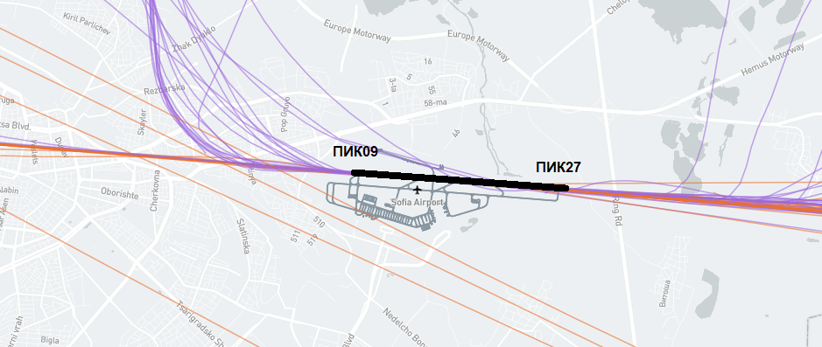

The selection of runway in use is carried out through a procedure established in accordance with the requirements of Commission Implementing Regulation (EU) 2017/373 of 1 March 2017 laying down common requirements for providers of air traffic management/air navigation services and other air traffic management network functions and their oversight and other network management functions related to the air traffic.

The procedure has been approved by DG CAA and published in the AIP Republic of Bulgaria, in section LBSF AD 2.21.4 Selection of RWY in use.
The AIP is available at the e-address: https://b-flip.bulatsa.com/ .

Selecting of RWY in use
The runway in use is the one that, at a certain period of time, depending on current MTO and traffic conditions is considered by Sofia Aerodrome Control Tower (Sofia TWR) to be the most suitable for take-off and landing.

As a rule, aircraft take-off and land against the wind, so the wind direction measured at the runway is a leading factor in choosing the runway in use.

Wind direction is an important, but not the only factor in selecting the runway in use. When determining the direction for take-off and landing, the following are also important:
- Wind speed - the recommended maximum tailwind speed on landing is 2.5 m/s;
- Wind shear
Wind shear is a change in wind speed and/or direction over a short distance. It can occur either horizontally or vertically and is most often associated with strong temperature inversions or density gradients. Wind shear can occur at high or low altitude. For airport operations low-level wind shears are of significance.
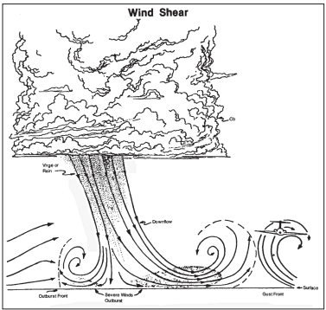
Four common sources of low-level wind shear are:
1. Frontal activity (the dynamic meeting points where contrasting air masses collide, driving significant shifts in temperature, pressure, and precipitation);
2. Thunderstorms.
3. Temperature inversions.
4. Surface obstructions
- Strong crosswind;
- Visibility - must be greater than 2,500 m;
- Cloudiness - the cloud ceiling should not be lower than 150 m, etc.

Wind direction alone, without taking into account other safety conditions, is not the only factor for determining the direction for take-off and landing of an aircraft.

Arrival, approach and departure procedures to/from Airport Vasil Levski - Sofia
Arrival, approach and departure procedures to/from Airport Vasil Levski - Sofia are prepared considering numerous factors, including:
- The topography of the area;
- Obstacles (objects built);
- The available radio navigation aids;
- The operational characteristics of the aircraft;
- The presence of residential areas, etc.

Procedures are designed to ensure the safety of both air traffic and residential areas in the vicinity of airports.

Due to the mutual location of the city of Sofia and the runway of Airport Vasil Levski - Sofia, the unconditional requirements for aviation safety require in some cases that aircraft fly over certain areas of the capital, because these are the only possible ways to safely arrive to or depart from the airport.

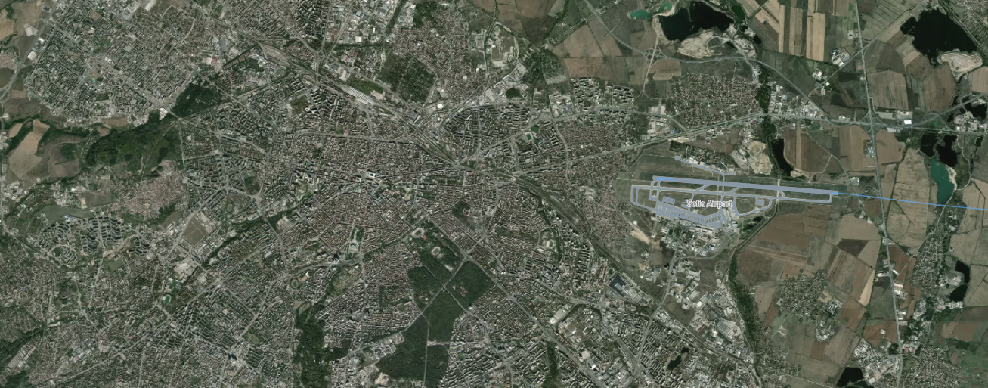

Procedures for arrival at Airport Vasil Levski - Sofia (landing)
During the approach, it is not possible to achieve a spatial distribution of aircraft trajectories, i.e. the aircraft to not pass over the same location every time, since in order to perform a safe landing, aircraft must position themselves along the runway axis approximately 15 km before the runway threshold. In this case, aircraft always land in a straight line that passes approximately over the same objects.

- With a prevailing westerly wind (the wind blows from west to east), aircraft land from the east, flying over the vicinity of the village of Petkovo, the town of Elin Pelin, the village of Musachevo, and the village of Krivina.

- With a prevailing easterly wind (the wind blows from east to west), aircraft land from the west, flying over the town of Bankya and the city of Sofia.

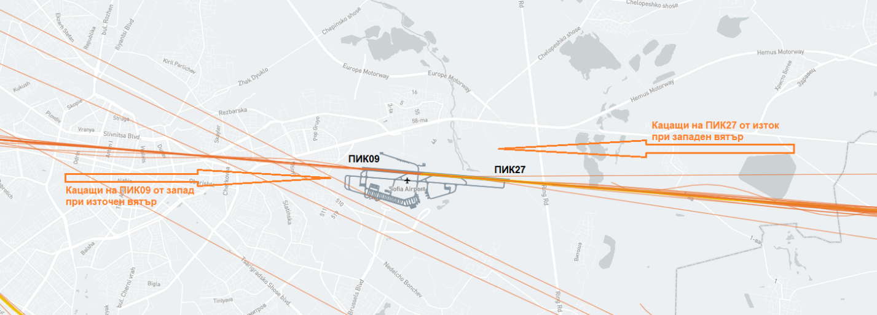

Procedures for departure from Airport Vasil Levski - Sofia (take-off)
During take-off, it is possible to achieve a spatial distribution of aircraft trajectories, i.e. the aircraft do not pass over the same place every time. This is possible because, depending on the specific flight parameters (aircraft type; passenger, cargo and fuel loading; wind direction and speed; air temperature; presence of precipitation, etc.) each aircraft gains the specified altitude and can make a turn to avoid populated urban areas at a different location.

- With a prevailing westerly wind (the wind blows from west to east), aircraft take off to the west, and after reaching a certain altitude, they turn north and fly over the residential quarters Vasil Levski, Suhata Reka, Hadzhi Dimitar, Orlandovtsi, Benkovski and Iliyantsi.

In this case, to avoid overflying the city of Sofia as much as possible, when departing from east to west, the aircraft are directed to the northwest. A southwesterly direction is not possible due to the Vitosha Mountain.
- With a prevailing easterly wind (the wind blows from east to west), aircraft take off to the east, and depending on the airport of destination, after take-off they fly over the villages of Dolni Bogrov, Gorni Bogrov, Chelopechene, Yana, etc.

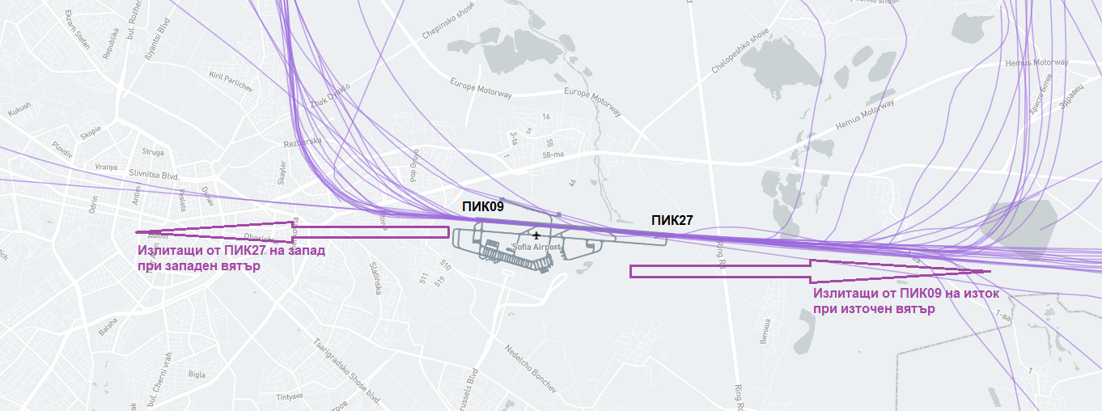

Roles and responsibilities during the different stages of flight

Take-off
Responsibility | Airport Operator | Aircraft (Pilot & Crew) | Tower (ATC)
Runway Condition | Ensures runway is clear, maintained, and safe | Checks for notices to aircraft pilots (NOTAMs) from the airport and airport conditions | Provides runway status updates
Clearance | N/A | Requests ATC clearance for taxi & take-off | Issues taxi and take-off clearance
Ground Movements | Manages ground vehicles | Follows taxi instructions | Controls ground traffic
Safety & Emergencies | Responds to incidents | Reports issues | Coordinates emergency response
Take-off Execution | N/A | Performs take-off per ATC instructions | Monitors traffic and authorizes departure

Approach
Responsibility | Aircraft (Pilot & Crew) | Tower (ATC) | Airport Operator
Receiving Approach Clearance | Confirms clearance and follows instructions | Issues approach clearance and monitors compliance | N/A
Navigation & Descent | Follows arrival and approach procedures | Provides vectors and sequencing | N/A
Communication & Coordination | Maintains contact with ATC and reports any anomalies | Coordinates with aircraft and other controllers | N/A
Weather & Runway Conditions | Checks weather notices and runway status | Provides weather updates and traffic advisories | Ensures runway is operational
Final Approach | Aligns with navigation aids for approach and stabilizes descent | Confirms landing clearance and manages spacing | Ensures no obstructions on the runway
Go-Around Execution (if needed) | Executes go-around if unstable or instructed | Issues go-around clearance if needed | Monitors and reports runway issues

Landing
Responsibility | Airport Operator | Aircraft (Pilot & Crew) | Tower (ATC)
Runway Preparation | Keeps runway clear and operational | Reviews approach briefings | Ensures runway is safe for landing
Approach Clearance | N/A | Follows ATC approach instructions | Guides aircraft through landing approach
Landing Execution | N/A | Lands according to ATC and airport conditions | Monitors and assists as needed
Taxi & Parking | Manages parking areas and gates | Follows taxiway instructions | Issues taxi and parking clearance
Emergency Handling | Responds to incidents | Reports any in-flight issues | Coordinates emergency response

